**PROJECT 2**

**CREATE AND INSERT INTO TABLE**

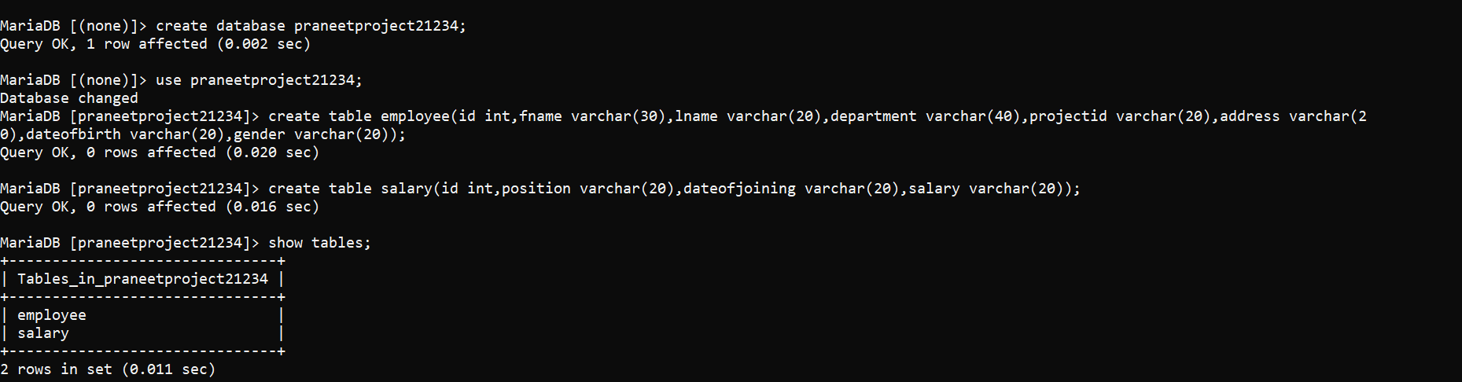

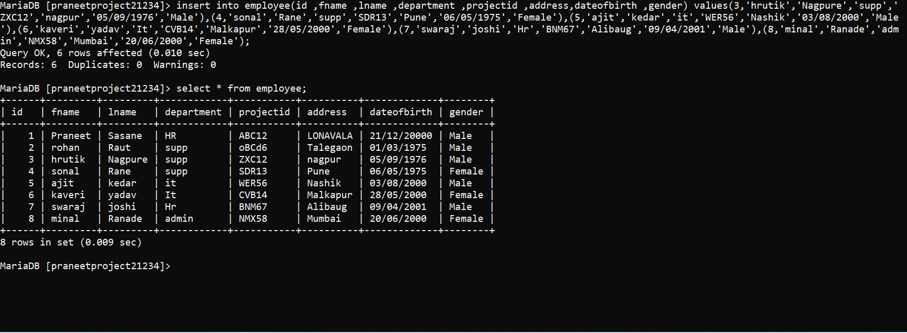

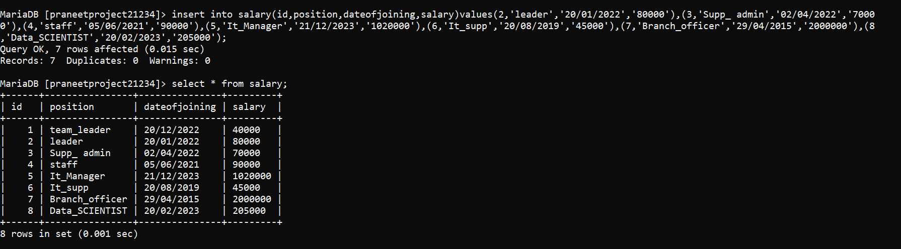

1.select UPPER(fname) as EmployeeName from employee;

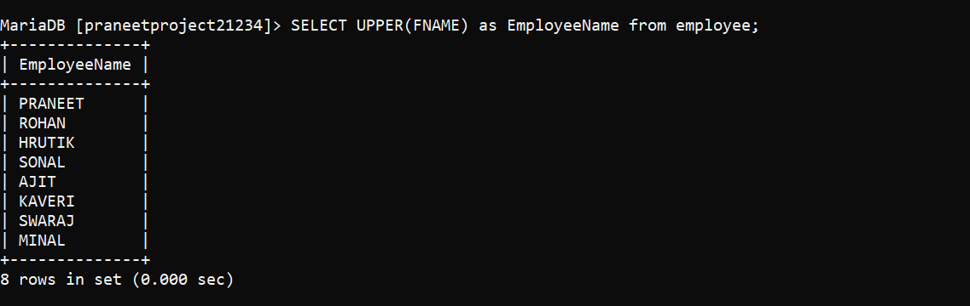

2.select count(department) from employee where department =’Hr’;

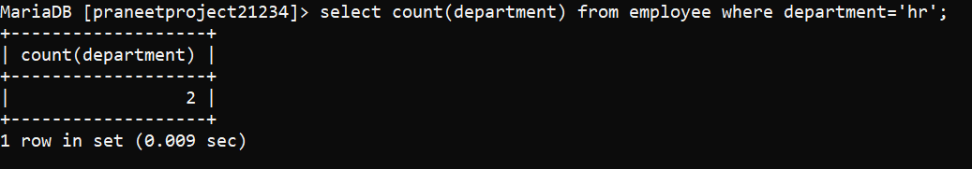

3.select substring (lname,1,4) from employee;

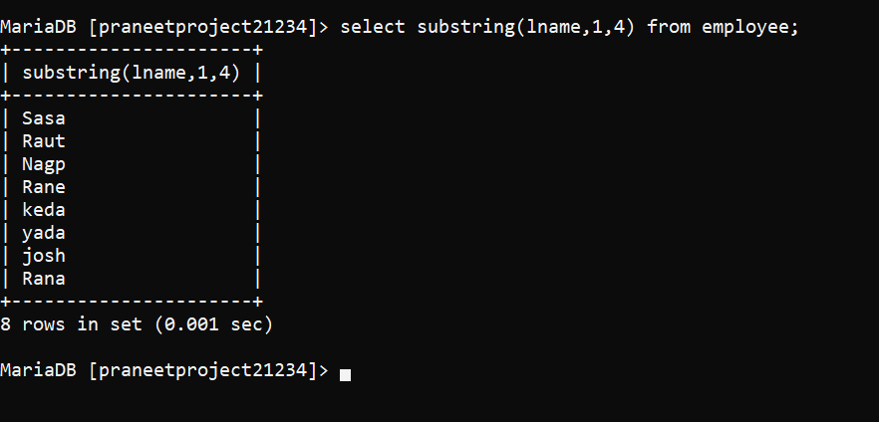

4.Rename table employee to sampletable;

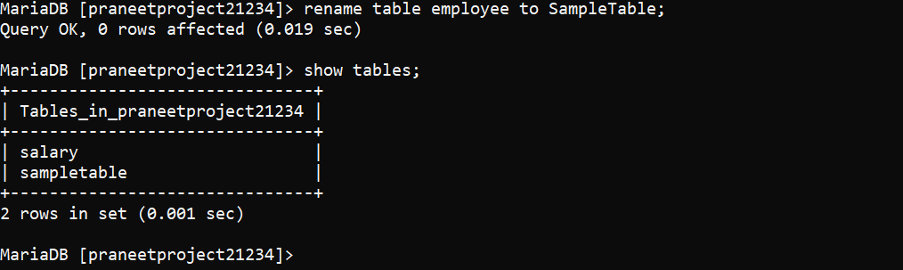

5.select fname from sampletable where name like ‘s%’;



6.select gender ,count(gender) from sampletable where dateofbirth between ‘1995/01/01’ and ‘1996/12/31’ group by gender;

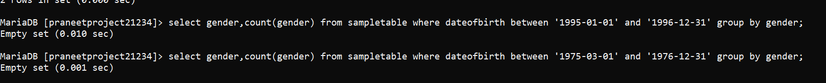

7.select * from sampletable s inner join salary m on s.id=m.sal_id;



8.select department ,count(*) from sampletable group by department;



9.select fname,projected ,count(*) from sampletable group by fname,projected having count (*)=1;

OR

Select DISTINCT (id),fname from sampletable;

